Additional Resources for Families. Please scan QR Code or access weblink

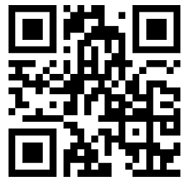 | NottAlone  Local mental health advice and help for young people in Nottingham and Nottinghamshire. If you are aged under 25, are a parent or carer, or a professional that supports young people, you can find information, advice and where to go to get help locally.  https://nottalone.org.uk/
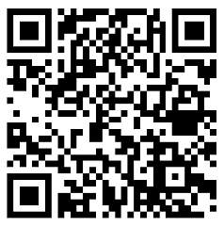 | Nottingham Children’s Hospital Community Paediatric leaflets  Help for Having a Healthy Headspace: concerns about a child or young person’s mental health or emotions.  Leaflets on ADHD, Autism Spectrum Disorder, Tics/Tourette’s  Sleep difficulties, and common medical concerns like constipation etc.  www.nuh.nhs.uk/childrens-leaflets?smbfolder=964
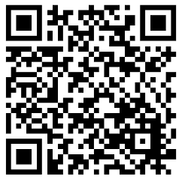 | Nottingham CITY: Ask Lion  www.asklion.co.uk  Excellent and easy to use site with information about organisations and services in the City of Nottingham. Where to get help with health, finances, housing, Special Educational Needs and Disabilities (SEND), support groups, and things to do.
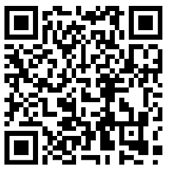 | Nottinghamshire COUNTY: Notts Help Yourself www.nottshelpyourself.org.uk  Excellent and easy to use site with information about organisations and services in the County. Where to get help with health, finances, housing, Special Educational Needs and Disabilities (SEND), support groups, and things to do.
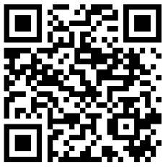 | Ask us Nottinghamshire  Impartial information, advice and support for parents / carers about Education and Special Educational Needs (SEND) from 0 - 25 years.  https://askusnotts.org.uk Tel: 0115 804 1740 enquiries@askusnotts.org.uk
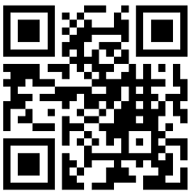 | Health For Teens: Website designed for teenagers that covers everything from relationships and sexual health to school to mental health to lifestyle. It also has extra sections for those in Leicestershire and Nottinghamshire. https://www.healthforteens.co.uk/
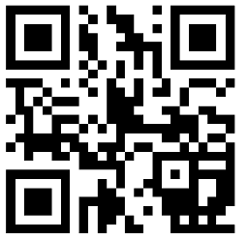 | Health For Kids: Has a section for adults (grown-ups) and a section for children. Has information and advice about health worries in children as well as extra sections for those living in the Nottingham area www.healthforkids.co.uk and www.healthforkids.co.uk/grownups/
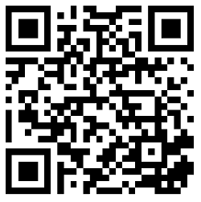 | Medicines For Children  Information for parents and young people about medicines, side effects, and other important useful information. Type in the name of the medicine or type of medicine to find the one you are looking for. Includes drugs for epilepsy, ADHD etc but also how to give medicines like tablets, drops, sprays etc.  www.medicinesforchildren.org.uk

